1. Biomass data was from Table 1. Meng believe the soil C pool data (“OC g/cc”) on Blanca’s datasheet were calculated from variable soil C data from Table 1 and Fig. 2. (MgC/ha).

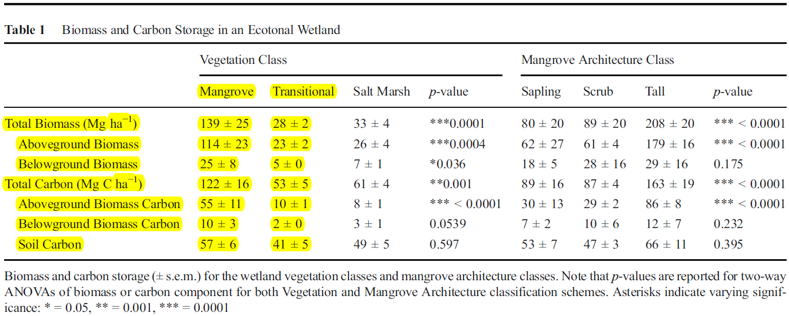

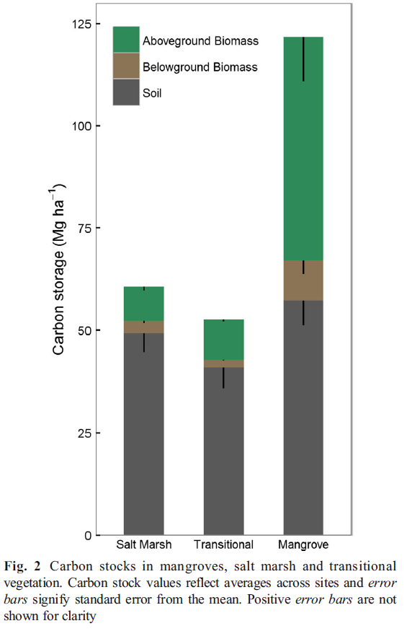

2. It should be noted that the unit of plant biomass for salt marsh (g/m2) and mangrove (g C/m2) are not the same on Blanca’s datasheet. In the updated datasheet by Meng, we chose the original C unit “Mg C ha-1” from Table 1 for biomass and soil.